List of Figures
Figure 1: Text-to-Video generation 4
Figure 2: Research Progression 6
Figure 3: Flowchart 7
Figure 4: High-level architecture of the "Text2Video-Zero" model 7
Figure 5: Gantt Chart 10

List of Tables
Table 1: Literature Review 5
Table 2: Components of high-level architecture of the "Text2Video-Zero" model 8
Table 3: Library/Tool used 9
Table 4: Project Timeline 10

Table of Contents
I. Introduction 4
II. Project Motivation 4
A. Blending Words with Vision 4
B. A New Era of Content Creation 4
C. Making Learning More Visual 4
D. Handling Big Data Challenges 5
E. Prioritizing User Experience 5
III. Literature Review 5
IV. Project implementation 6
A. Data Collection & Preprocessing 6
B. Feature Extraction 6
C. Model Implementation & Training 6
D. Evaluation 7
E. User Interface Development 7
V. Methodology 7
VI. Dataset 8
A. Source 8
B. Key Features of the Dataset 8
1) Diversity 8
2) High-Resolution 8
3) Annotated Data 9
4) Temporal Consistency 9
VII. ML Libraries 9
VIII. Timeline 10
F. Timeline 10
G. Gantt Chart 10
IX. Scope Limitations of the Text2Video-Zero Implementation 10
X. Conclusion 11
References 11

Introduction
The field of artificial intelligence continually seeks to break barriers between different forms of media. At the forefront of this endeavor stands the research titled "Text2Video-Zero: Text-to-Image Diffusion Models are Zero-Shot Video Generators" conducted by Picsart AI Research Lab [1]. This study introduces a method that converts textual descriptions directly into videos, marking a significant advancement in the integration of natural language processing and computer vision. Such a development not only addresses the growing demand for dynamic visual content but also showcases the potential of machines to interpret and render human language in a visual format. By offering a solution to the challenge of text-to-video synthesis, the research sets a new benchmark for interdisciplinary studies in artificial intelligence.
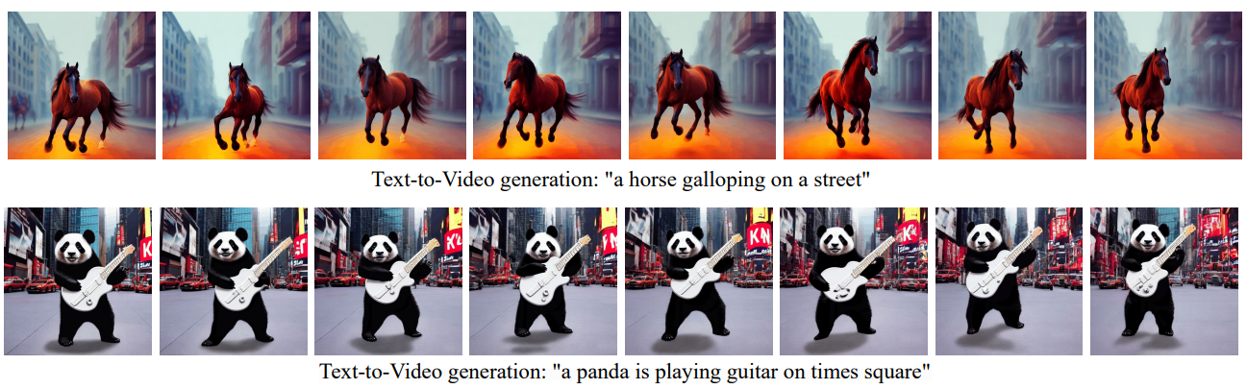
Figure 1: Text-to-Video generation [1]

Project Motivation
In an era where visual storytelling is paramount, the ability to convert textual narratives into dynamic videos holds transformative potential. As platforms and audiences increasingly favor visual content, the research from Picsart AI Research Lab, titled "Text2Video-Zero: Text-to-Image Diffusion Models are Zero-Shot Video Generators," emerges as a timely and innovative response to this demand [1]. Delving into its significance reveals:
- Blending Words with Vision: The initiative by Picsart AI Research Lab offers a novel approach, merging the realms of text interpretation and visual representation. This is not just about generating images; it's about crafting a coherent visual story based on textual cues.
- A New Era of Content Creation: With the digital landscape being saturated with content, differentiation becomes key. A tool that can take textual descriptions and produce videos offers a unique edge, streamlining content creation and offering bespoke visual outputs.
- Making Learning More Visual: In education, the value of a tool that can translate textual concepts into visual content is immeasurable. It offers a tangible way to represent abstract ideas, catering to a broader spectrum of learners.
- Handling Big Data Challenges: The emphasis on utilizing large image datasets signifies the project's ambition to operate at scale, ensuring that vast amounts of data can be processed without compromising on the quality of the generated videos.
- Prioritizing User Experience: By integrating a user interface, the project underscores its commitment to accessibility. It's a nod to the importance of ensuring that such groundbreaking technology is usable and beneficial to a wide audience.
In summary, the research by Picsart AI Research Lab is not just academically intriguing; it addresses a contemporary need, offering a solution that aligns with the evolving preferences of today's digital consumers.

Literature Review
The journey towards the synthesis of textual narratives into visual content has been paved by several groundbreaking works, each contributing a piece to the puzzle. The following literature chronicles this progression, leading up to the innovative "Text2Video-Zero: Text-to-Image Diffusion Models are Zero-Shot Video Generators" by Picsart AI Research Lab:
Table 1: Literature Review
Year | Research Title | Authors | Contribution | Description
2014 | Generative Adversarial Networks (GANs) [2] | Ian Goodfellow et al. | Introduction of GAN architecture | - Introduced the concept of two competing neural networks  - Laid the foundation for image generation advancements [2]
2014 | Large-Scale Video Classification with Convolutional Neural Networks [3] | Karpathy et al. | Insights into large-scale video generation | - Delved into intricacies of video data  - Emphasized need for optimized computational processes [3]
2016 | Generating Videos with Scene Dynamics [4] | Vondrick et al. | Exploration of video generation from cues | - Explored generation of short video clips  - Provided insights into text-to-video synthesis challenges [4]
2021 | DALL·E [5] | OpenAI | Advancements in text-to-image synthesis | - Generated diverse images from textual prompts  - Bridged language and visuals [5]
2021 | Diffusion Models [6] | Prafulla Dhariwal and Alex Nichol | Emphasis on iterative refinement | - Demonstrated effectiveness in high-quality image production  - Highlighted potential of iterative techniques [6]

The following timeline visually represents the sequence of foundational works providing a clearer understanding of the research progression.
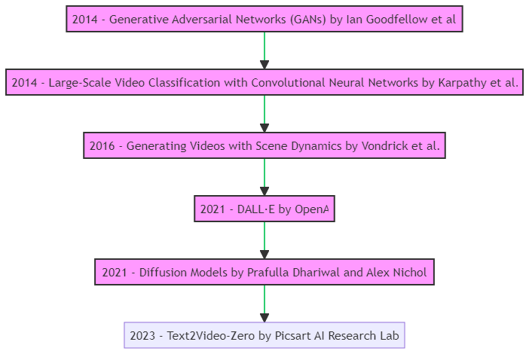
Figure 2: Research Progression

Project implementation
The primary objective of this project is to implement and evaluate the "Text2Video-Zero: Text-to-Image Diffusion Models are Zero-Shot Video Generators" model. This model promises to convert textual descriptions directly into videos, a significant advancement in the realm of AI-driven content generation.
The flowchart illustrates the sequential steps involved in the project:
- Data Collection & Preprocessing: The initial stage involves sourcing and preparing the dataset.
- Feature Extraction: This step focuses on extracting relevant features from both textual and visual data.
- Model Implementation & Training: Here, the "Text2Video-Zero" model is adapted and trained.
- Evaluation: The model's performance and the quality of generated videos are assessed.
- User Interface Development: The project concludes with the creation of a user-friendly interface.
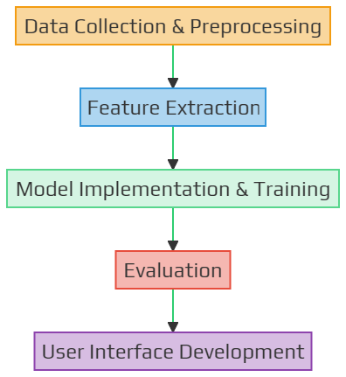
Figure 3: Flowchart

Methodology
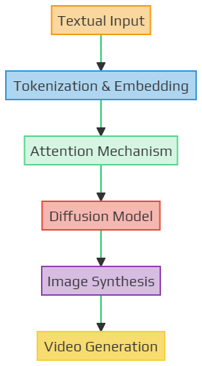
Figure 4: High-level architecture of the "Text2Video-Zero" model [1]
Table 2: Components of high-level architecture of the "Text2Video-Zero" model
Component | Description | Function
Textual Input | The starting point where a textual description or narrative is provided to the model. | Acts as the primary source of information that the model will use to generate visual content.
Tokenization & Embedding | The textual input is broken down into smaller chunks or tokens and then converted into numerical vectors. | Facilitates the model's understanding of the textual content by representing words or phrases in a format suitable for processing.
Attention Mechanism | A technique that allows the model to focus on specific parts of the textual input that are more relevant for the current task. | Enhances the model's capability to generate coherent visual content by emphasizing important textual cues.
Diffusion Model | The core of the "Text2Video-Zero" approach, responsible for the iterative refinement of the generated content. | Enables the model to produce high-quality images by refining the generated content over multiple iterations.
Image Synthesis | The model generates a static image based on the refined content from the diffusion model. | Acts as an intermediary step before video generation, ensuring that the initial frame or image aligns well with the textual description.
Video Generation | The model extends the synthesized image into a coherent video sequence, adding dynamic elements to the visual content. | Produces the final output, a video that visually represents the provided textual narrative.

Dataset
- Source: While there are several datasets available for image generation tasks, for this project, datasets like COCO (Common Objects in Context) or ImageNet could be considered due to their vastness and diversity. Additionally, datasets specifically designed for video tasks, like UCF101 or Kinetics, might be explored to understand temporal dynamics.

Key Features of the Dataset:
- Diversity: The dataset will include images from various categories, ensuring that the model can handle a wide range of textual prompts.
- High-Resolution: To generate quality videos, the dataset will prioritize high-resolution images.
- Annotated Data: Each image in the dataset will be paired with textual descriptions, aiding in supervised training.
- Temporal Consistency: For video generation, the dataset will also include sequences of images that showcase movement or change over time.

ML Libraries
The successful implementation of the "Text2Video-Zero" model requires a combination of specialized tools and libraries, each tailored to handle specific tasks within the project. The following table provides a comprehensive overview of these essential components, detailing their specific roles and features:
Table 3: Library/Tool used
Component | Library/Tool | Specific Role & Features
Programming Language | Python | - Core language for the project.  - Offers a wide range of libraries and frameworks for machine learning and data processing.
Deep Learning Framework | TensorFlow [7] | - Build, train, and deploy ML models.  - TensorFlow Extended (TFX) for end-to-end platform components.  - TensorFlow Hub for reusable model components.
 | PyTorch [8] | - Dynamic computation graph for flexibility.  - TorchVision for computer vision tasks.  - Native support for neural network architectures.
Image & Video Processing | OpenCV [9] | - Image and video capture, processing, and manipulation.  - Feature extraction and object detection.  - Integration with deep learning frameworks.
Natural Language Processing | HuggingFace's Transformers [10] | - Pre-trained models like BERT, GPT-2, and T5.  - Tokenization and embeddings for various languages.  - Pipelines for common NLP tasks.
User Interface Development | Streamlit [11] | - Rapid development of data applications.  - Interactive widgets for user input.  - Data visualization and plotting.
 | Flask [12] | - Micro web framework for Python.  - Flask-RESTful for building APIs.  - Flask-Bootstrap for integrating Bootstrap with the application.
Dataset Handling | Pandas [13] | - Data manipulation and analysis.  - DataFrame structure for tabular data.  - Data cleaning, aggregation, and visualization.
 | NumPy [14] | - Numerical operations and computations.  - Array and matrix data structures.  - Mathematical functions for linear algebra and statistics.

Timeline

Timeline
Table 4: Project Timeline
Date | Task
Oct 1 | Project Description/Proposal Submission
Oct 2 - Oct 6 | Conference with Instructor
Oct 7 - Oct 15 | Data Preprocessing
Oct 16 - Oct 23 | Model Development
Oct 24 - Oct 31 | Training Phase I & Progress Report
Nov 1 - Nov 10 | Training Phase II & UI Development
Nov 11 - Nov 15 | Testing & Debugging
Nov 16 - Nov 19 | Finalization, Documentation & Submissions
Nov 22 | PPT File Submission
Nov 23 - Nov 24 | Project Presentations

Gantt Chart
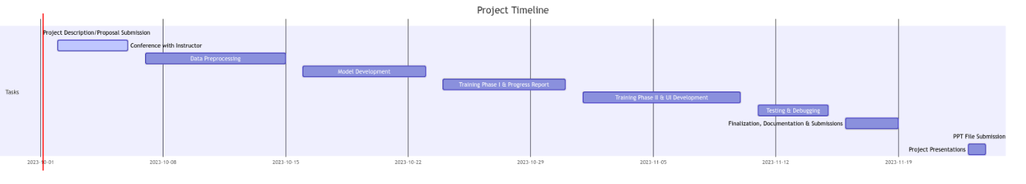
Figure 5: Gantt Chart

Scope Limitations of the Text2Video-Zero Implementation
While the ambition of this project is to faithfully implement the "Text2Video-Zero: Text-to-Image Diffusion Models are Zero-Shot Video Generators" model, several factors might limit its scope. The quality and diversity of the vast image dataset can significantly influence the model's performance, with inconsistent or biased data potentially leading to suboptimal results [1]. The computational demands of the model, especially during the training phase, might be constrained by available resources, potentially extending training durations or limiting the model's complexity.
Additionally, the model's generalization capabilities could vary based on the intricacy and ambiguity of the input text. The user interface, designed for seamless interaction, might face real-time video generation latencies due to server loads or input complexities. Lastly, the project's reliance on specific machine learning libraries means that unforeseen updates or changes in these libraries could introduce challenges or deviations in the intended functionality.

Conclusion
Project aims to implement the "Text2Video-Zero" model marks a pivotal step in AI-driven content creation. By transforming text into video, we address both technical challenges and the broader implications for the future of machine learning applications. As we progress, our focus remains on precision, user experience, and setting new standards in text-to-video synthesis.

References
[1] | L. Khachatryan et al., “Text2Video-Zero: Text-to-Image Diffusion Models are Zero-Shot Video Generators,” arXiv:2303.13439, March 23, 2023, https://arxiv.org/abs/2303.13439 [Accessed: October 1, 2023].
[2] | I. J. Goodfellow et al., “Generative Adversarial Networks,” arXiv:1406.2661, 2014, https://arxiv.org/abs/1406.2661 [Accessed: October 1, 2023].
[3] | A. Karpathy et al., “Large-Scale Video Classification with Convolutional Neural Networks,” 2014 IEEE Conference on Computer Vision and Pattern Recognition, June 2014, https://doi.org/10.1109/cvpr.2014.223 [Accessed: October 1, 2023].
[4] | C. Vondrick, H. Pirsiavash, and A. Torralba, “Generating Videos with Scene Dynamics,” arXiv:1609.02612, October 26, 2016, https://arxiv.org/abs/1609.02612 [Accessed: October 1, 2023].
[5] | OpenAI Research Lab, “DALL·E: Creating images from text,” https://openai.com/research/dall-e [Accessed: October 1, 2023].
[6] | P. Dhariwal and A. Nichol, “Diffusion Models Beat GANs on Image Synthesis,” arXiv:2105.05233, June 2021, https://arxiv.org/abs/2105.05233 [Accessed: October 1, 2023].
[7] | M. Abadi et al., "TensorFlow: An end-to-end open source machine learning platform," TensorFlow Documentation, 2021, https://www.tensorflow.org/api_docs [Accessed: October 1, 2023].
[8] | A. Paszke, S. Gross, and G.S. Chintala, "Pytorch: An Open Source Machine Learning Framework," PyTorch Documentation, 2016, https://pytorch.org [Accessed: October 1, 2023].
[9] | Opencv, “Opencv/opencv: Open source computer vision library,” GitHub, https://github.com/opencv/opencv [Accessed: October 1, 2023].
[10] | T. Wolf et al., “HuggingFace’s Transformers: State-of-the-art Natural Language Processing,” arXiv:1910.03771, February 2020, https://arxiv.org/abs/1910.03771 [Accessed: October 1, 2023].
[11] | Streamlit Documentation, “Streamlit Docs,” https://docs.streamlit.io/ [Accessed: October 1, 2023].
[12] | Flask Documentation, “Welcome to Flask — Flask Documentation (3.0.x),” https://flask.palletsprojects.com/en/3.0.x/ [Accessed: October 1, 2023].
[13] | Pandas Documentation, “Pandas: powerful Python data analysis toolkit — pandas 0.9.1 documentation,” https://pandas.pydata.org/pandas-docs/version/0.9.1/index.html#:~:text=pandas%20is%20a%20Python%20package [Accessed: October 1, 2023].
[14] | Numpy, “NumPy,” Numpy Documentation, 2009, https://numpy.org/ [Accessed: October 1, 2023].

